Below is the result of experiment that tested in two different specs with the same input (3000 rupiah) and same code of algorithm to.

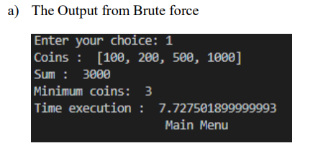

Figure 1. Brute Force (using intelcore i5)

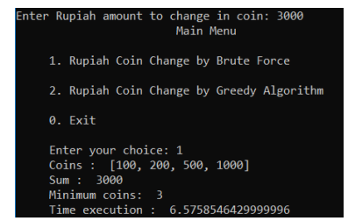

Figure 2. Brute Force (using intelcore i7)

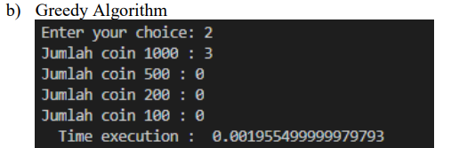

Figure 3. Greedy Algorithm (using intelcore i5)

